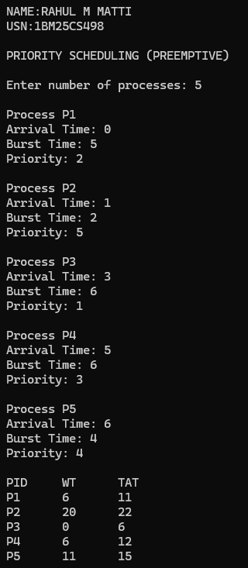
PRIORITY SCHEDULING(PREEMPTIVE)

PRIORITY SCHEDULING(NON PREEMPTIVE)
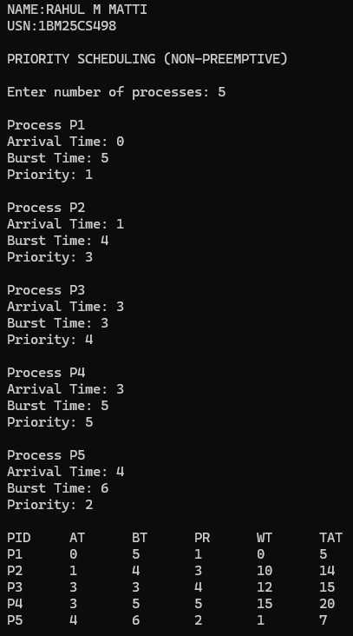

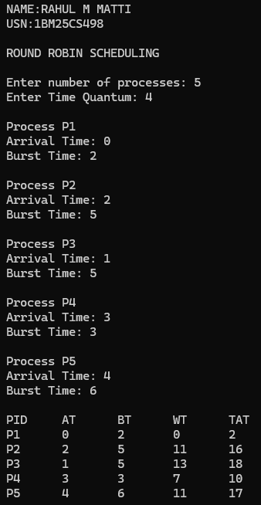
ROUND ROBIN

